

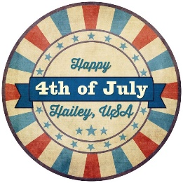

2026 4th of July Parade Participation Waiver and Safety Agreement
Participant Name: _________________________________________
Organization (if applicable): ________________________________
In consideration of being permitted to participate in the Hailey 4th of July Parade, I acknowledge and agree to the following terms:

General Liability Waiver
I hereby release and hold harmless the City Of Hailey & The Chamber of Commerce, its employees, volunteers, sponsors, and all associated agencies and organizations from any and all liability, claims, demands, and causes of action whatsoever for injuries, losses, or damages to person or property that may arise out of or in connection with participation in the 4th of July Parade, including travel to and from the event.
I understand that participation is voluntary and at my own risk.

Safety Rules Acknowledgement
For the safety of parade participants and spectators, I agree to follow these safety guidelines:
- Absolutely NO items (including candy, toys, flyers, beads, etc.) may be thrown from any moving vehicle or float.
- All candy and giveaway items must be handed out by individuals walking alongside the float, close to the curb, to ensure safe and controlled distribution.
- All walking participants must remain aware of their surroundings and stay safely distanced from the wheels of any moving vehicles.
- Drivers must maintain a slow, steady pace and follow all instructions from parade officials.
- All floats and participants must comply with local laws and parade regulations.
- Absolutely NO strong political messaging of any kind. This includes divisive topics and themes whether bi-partisan or not that are used to invoke a strong emotional reaction from the public.
Failure to adhere to these rules will result in a fine as well as exclusion from future events.

Signature
By signing below, I affirm that I have read and understand this waiver and agree to abide by all safety rules and regulations outlined above.
Participant Signature: _______________________________________
Date: ________________________

