Benefits Description | Bull Rider (3) | Bronc Buster | Barrel Racer | Roping | Mutton Buster | Friend
 | $3,000 | $2,000 | $1000 | $750 | $500 | Under $250
Logo on Main Street Banner | Yes | Yes | - | - | - | -
Parade Signage | Individual sign at announcement booths | Individual sign at announcement booths | Individual sign at announcement booths | Group Sign | - | -
Parade Announcement | Multiple Individual Announcement/Ad | One Individual Announcement/ Ad | - | - | - | -
Parade Mention as Sponsor | Yes | Yes | Yes | Yes | - | -
Logo/Listing Newsprint Ads | Logo - Top Placement | Logo | Listing | Listing | - | -
Social Media Posts | Yes - 3 | Yes - 2 | Yes - 1 | Yes – Group Post | - | -
Chamber Newsletter Mention | Yes | Yes | Yes | - | - | -
Logo/Listing Event Poster | Logo - Top Placement | Logo | Listing | Listing | - | -
Logo/listing on web page | Yes | Yes | Listing | Listing | Listing | -
Parade Entry Fee | Complimentary | Complimentary | Complimentary | Complimentary | Complimentary | Complimentary
Reserved Seating at Parade | Yes | - | - | - | - | -
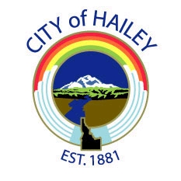
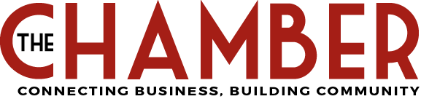
Hailey 4th of July
Parade and Fireworks
Sponsor Levels and Benefits

