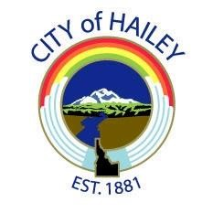

2023 Fourth of July
Parade and Fireworks
Sponsorship Commitment Form

Business Name: _________________________________________________________________________

Contact Name: __________________________________________________________________________

Contact Phone: _________________________________________________________________________

Email Address: _________________________________________________________________________

Mailing Address: _______________________________________________________________________

City: _______________________________ State: _________________ Zip: ___________________

______Yes, I would like to commit as a 4th of July Sponsor. Please check one.

- $3,000 Bull Rider
- $2,000 Bronc
- $1,000 Barrel Racer
- $750 Roping
- $500 Mutton Buster
- $250 Friend

____I have enclosed a check for my sponsorship amount.

____Please invoice me.

____Please call me for Credit Card information

____I would like to pay with a Credit Card, my information is:

Card# __________________________________________ Card Type: __________________

Expires _____________ Security Code (CSC) __________

Please return this form to:
The Chamber, PO Box 100, Hailey, ID 83333,
Email: info@valleychamber.org or Fax: 208.578.1595

